

**ACADEMY OF DENTAL MATERIALS**

**NEWSLETTER**

www.academydentalmaterials.org

**Lorenzo Breschi, Secretary ADM November, 2008.**

**Message from the President**

When I agreed to be Secretary of the Academy with the prospect of becoming President in several years, I did not realize how many responsibilities are part of this task.

An issue I want to address with the board during the upcoming years is to remember our roots, and to re-evaluate the long way the Academy has come.

In the first issue of Dental Materials (1985; 1: 1-2) Marshall W Jr, Marshall SJ, Bayne SC and Greener EH pointed out the history of the Academy of Dental Materials reorganized in 1983 under the leadership of Dr. Greener after being found in 1941 as American Academy for Plastics Research in Dentistry. Also they indicated the board composition with several ‘regional liaisons’. The objectives of the Academy were: 1) to provide a forum for the exchange of information on all aspects of dental

materials; 2) to enhance communication between industry, researchers and practicing dentists; 3) to encourage dental materials research and its applications; and 4) to promote dental materials

through its activities. All these objectives are still valid but we have to add something else. We are now in the era of globalization with all its peculiarities. The use of computers, of internet and emails have drastically changed the habits of many of us and the dental science area is deeply involved in and affected by these changes. Dental research is undergoing organizational changes, including the establishment of some international scientific networks. An international scientific network can be created at different levels, starting with cooperation at the professor, researcher, undergraduate, postgraduate and PhD levels, based on an exchange of students and scientists. In particular, at the postgraduate and PhD levels, the exchange of students can be very beneficial in terms of the stimulus and support to dental research. The question of how large an international scientific network should be is difficult to answer. It is likely cooperation among schools can be achieved by a few of them and can be focused on a common scientific interest, but if the scientific network is promoted by a well-known institution such as the ADM, the reach can be much wider. To do that, we need to have a bigger presence in different areas of the world, giving more visibility to the ADM all around.

During the last annual meeting in Wurzburg, three past-presidents (Jack Ferracane, Susanne Scherrer and Dorin Rose) were appointed as members-at-large to the board for a 1 year term. This is an exceptional situation due to the simultaneous change of all members-at-large. Three new members-at-large were elected (Laurence Mair, Paulo Cesar and Burak Taskonak) for a regular term of 4 years and next year, three others (Paulette Spencer, Ulrich Lohbauer and Nick Silikas) will take over as members-at-large on the board. This will re-introduce a stagger in the expiration of board members terms, so that we do not have a repeat of the situation where virtually the entire board would need to be replaced at once. We want to thank Jack, Susanne and Dorin for once again serving the Academy.

The new web site is under construction. Thanks to Sharukh Khajotia and Paulo Cesar, who have put in a lot of work on this project. The new website will permit automated dues payment, conference registration, and abstract submission. A sincere thanks to David Watts and the Editorial Board for achieving such a high impact factor for the journal.

Next year’s conference will be held October 29-31 in Portland, Oregon, under the organization of Jack Ferracane, Ron Sakaguchi, and Tom Hilton. An outstanding program is prepared and we expect a high attendance (detailed information at the end of the newsletter). One year later the meeting will be held in Trieste, Italy (October 8- 10, 2010), under the local organization of Lorenzo Breschi, our new secretary, and the final program will be available shortly. You will find it soon on the new website.

I wish you all and your families good health, peace and success in the upcoming New Year.

**Marco Ferrari**

**President, ADM (2009-2010)**

# Tresurer’s Report

The Academy is in good financial shape. Our cash/cash-equivalent assets stand at $387,808 as of the 2008 annual meeting. Current membership is 294. The biannual review of the Academy’s finances was conducted by Woodbridge and Erickson, CPAs, Portland, Oregon, USA. This review found our financial statements to be in conformity with generally accepted accounting principles. There were two recommendations offered by the auditors:

1. The Academy currently has approximately $235,000 in excess of federally insured limits as of December 31, 2007. We have discussed this issue in the past with our accountant, and he did not feel that this posed any particular financial risk to the Academy. However, given the recent turmoil in the US financial markets, he recommended that we disperse our excess cash to additional bank(s)to provide more security of the Academy’s assets. At the time of this report, FDIC protection of bank accounts was limited to $100,000 per bank (this has recently been increased to $250,000).
2. The auditors also expressed some concern that the Academy’s assets are reaching a point that our tax-exempt status may not be looked upon favorably by the U.S. IRS (tax collection agency), and that the Academy may want to consider actions that would decrease our assets.

**Tom Hilton**

**Treasurer ADM (2008-2012)**

**Dental Materials Editors’ Report October 2008**

The journal has received an encouraging increase in Impact Factor. This is now 2.990 and we are ranked as # 4 out of all dental journals. A big “thank you” is due to all those who have helped to achieve this result – especially the authors, reviewers and editorial teams. And special thanks to our Presidents – most recently Jason and now Marco - for their support. The consequences of popularity are increased submissions and this has meant that the rejection rate has had to rise to 70 % (still lower than, e.g., *J Dentistry* which is 90 %!).

To partly address this, the ADM Board and Editorial Board have agreed with Elsevier Science to add additional “e-only pages”. This is to publish ADM Conference abstracts and also selected full manuscripts, for example reviews with extensive reference lists and FEA papers with extensive color figures. The status of such papers is entirely equivalent to those published in the print journal. Since the vast majority of papers are accessed by readers via PDF downloads from the online journal, there is little practical difference between e-only and print versions of papers. In 2007 there were over 360,000 downloads from our journal. This number is likely to increase!

**David Watts**

**Editor**

# Academy Membership Renewal

Our website is currently undergoing major upgrades which will include the option to renew memberships online. This will be a secure site that will allow payment by credit card. The site is still in the test stages so, at this time, please continue to return your renewal forms via email, fax or postal mail. An email notification will be sent to all members when the new website is available so please confirm your email address on your renewal forms.

# Dea Dea Hilton

**Fellowships and Awards**

## Fellowships

This year the following members have been elevated to Fellowship status:

**Ulrich Lohbauer** (University of Erlangen-Nuernberg, Germany)

**Klaus Jandt** (University Jena, Germany)

**Simone Grandini** (University of Siena, Italy)

**Raphael Pilo** (University of Tel Aviv, Israel)

**Cecilia Goracci**(University of Siena, Italy)

# Emeritus Status

Congratulations to Joseph von Fraunhofer, he was granted Emeritus status unanimously by the Board

If you **wish to be considered for Fellowship** of this Academy then you should consider the criteria for Fellowship as stated below.

**Fellows** shall be active Members who have attained a high level of achievement in the field of dental materials research. Those Members who are recognized to have advanced dental materials research shall be considered for Fellowship by the Fellowship and Awards Committee. Members awarded Fellowship status shall be inducted into Fellowship at the next annual meeting. Fellows maintain the same rights, privileges, and responsibilities of Members.

Specific **guidelines** for Fellowship status are:

- Achievement of advanced degrees: at least a master's degree and preferably a Ph.D., Odont Dr., or equivalent degree;

- Evidence of contribution: publication of at least ten (10), peer-reviewed, scientific articles in refereed journals. The candidate should be first author on one-half of the articles; and

- Longevity of commitment to the field: at least five (5) years of leadership through research, training, service and/or education beyond formal education, and normally at least five (5) years membership in the Academy.

If you are interested in becoming a Fellow of this Academy then please submit a *curriculum vitae* and letters of recommendation from a minimum of two Fellows of the Academy to the secretary: Lorenzo Breschi, email: [lbreschi@units.it](mailto:lbreschi@units.it)

# Paffenbarger Award

This competition recognizes students who present the most excellent research at our annual conference. This year the winners are:

1. **Paul Hooi** (Dublin Dental School and Hospital) Quantifying ceramic resin strengthening by varying resin elasticity;
2. **Yu-Chih Chiang** (Ludwig-Maximilians-University) Deformation analysis of composite polymerization shrinkage from micro ct images;
3. **Muhanad Hatamleh** (University of Manchester) Color changes of maxillofacial silicone elastomer due to extra-oral aging.

First place, which is the Paffenbarger award, received a plaque, a money prize of US $750 and free registration for the following ADM meeting; second place received a certificate, a money prize of US $250 and free registration for the following ADM meeting; and third place received a certificate and free registration for the following ADM meeting.

**Burak Taskonak**

**Member at Large ADM (2008-2012)**

# Future Meetings

Please reserve the following dates on your calendar. We look forward to the upcoming meeting in:

**2009**: **Portland*,*OregonOctober 29-31, 2009**

**2010: Trieste (Italy) October 8-10, 2010**

Detailed program and info for the 2009 meeting are reported at the end of the newsletter.

**In Memoriam**

**Janet B. Quinn, BS, MS, PhD (1950-2008)**

With great sadness we announce that Dr. Janet Bernice Quinn passed away in the early morning of Saturday, July 19, 2008 after a brief but difficult battle with cancer. Dr. Quinn was a Project Leader for the ADA Foundation Paffenbarger Research Center, beginning her employment in the winter of 1999. Her latest research on dental fractography received several grant awards from the National Institutes of Health and the Rockefeller Brothers Fund. This project was a direct outcome of the collaboration between only a handful of researchers in this field. Janet created and organized the first dental fractography hands-on course in May 2007 at the National Institute of Standards and Technology, the goal being to understand dental restoration failure modes, produce guidelines and recommendations for needed improvements in dental restoration longevity and disseminate the relevant information. The success of this first course attended mainly by the dental material’s community was an encouragement to repeat it in May 2008 as seen in the picture below taken at the end of the course, a few days before her terrible diagnosis of lung cancer.

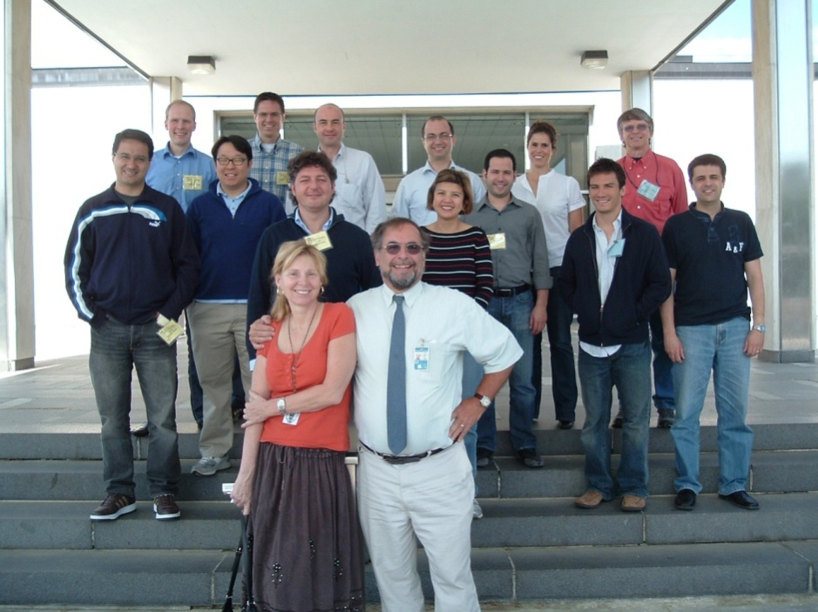

Janet and George Quinn at the last fractography course at NIST May 2008

Once labeled a ‘lone wolf’ by a grant reviewer, Janet proudly displayed the written criticism until she was later exonerated by the NIH Scientific Review Panel when they chose Janet’s visionary work for funding. Her studies on dental restoration failure analysis garnered international recognition, with awards from the American Ceramic Society, Department of the Army, and an invited speaker position at the 1997 European Ceramics Conference in Versailles, France and at the 2003 meeting of the Academy of Dental Materials in Geneva, Switzerland, to name a few. Janet was a passionate collaborator who encouraged all who she worked with to explore beyond the current paradigm, and thus earned the reputation as a visionary leader in dental materials science.Janet was also an accomplished writer, authoring more than 40 publications.

Janet received her B.S. (1973) and M.S. degrees (1975) in Mechanical Engineering from Northeastern University (Boston), and Ph.D. in Materials Science and Engineering from the University of Maryland, College Park, (2000). During the late 1970’s to 1991, she worked at the U.S. Army Materials Testing Laboratory in Watertown, MA while raising her two children George W. and Aleta. She developed the method of using artificial flaws to initiate slow crack growth and subsequent time-dependent failure in ceramics. This work lead directly to the use of fracture maps in ceramic evaluation. Janet also designed and implemented a program of controlling parameters and testing procedures to optimize slipcasting. This included innovative use of porosimetry and non-destructive testing methods, for which she received in 1991 a Department of the Army Commendation.

From 1991 until 2000, Janet worked as an Engineering Consultant at the National Institute of Standards and Technology (NIST) in Gaithersburg, MD, where she designed and implemented ceramic testing programs. This included biaxial testing of BK-7 glass under various environments for airplane windows, tensile testing of ceramic fibers, and determining fracture energies of single crystals. The fracture energy work has led to a newly-defined brittleness parameter for ceramics and an American Ceramic Society Engineering Ceramics Division First Prize for Technical Presentation (1995).

Janet did not limit her accomplishments to science, however. She was also an active member of the Washington Area Middle Eastern Dance Association, instructor of multi-level dance courses, and organizer of numerous charity performances.

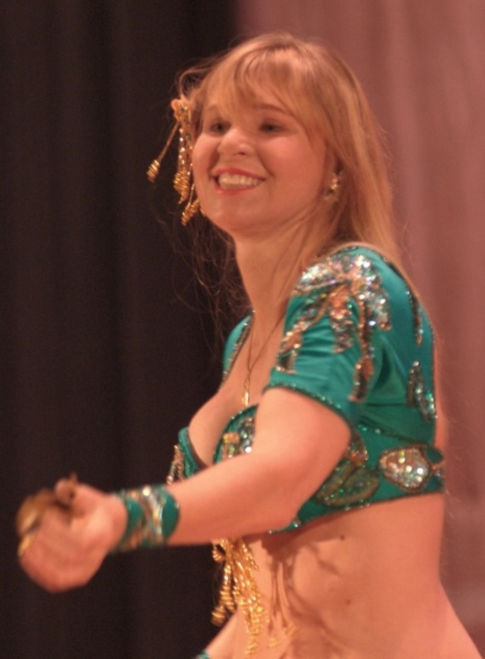Janet loved to share - the sensuous and vibrant movements, the Middle Eastern music, the history, and of course, the glittering pageantry of the cabaret costumes. She trained hundreds of students in three languages in Boston, Washington, and Cologne, Germany and Strasburg, France. She attended and had a lot of fun at the Dance Camp the Memorial Day weekend in May 2008, shortly before her dental fractography course and just days before her sad diagnosis. Janet, known under her artist name Aliya, had her own home web page under http://www.aliyaquinn.com/

Janet had such a wonderful personality that she almost immediately endeared herself to almost everyone who met her. Her joy of life and her willingness to help all people brought sunshine into the lives of her many loved ones, professional colleagues, and dance friends around the world. Everyone without exception remembers her warm smile.

Janet Quinn was an inspiration to many and will be missed by all. She is survived by her husband, George D. Quinn, children Aleta and George W., mother Florence Gorcenski, brother Edward Gorcenski and sister Cynthia Kazmer.

**Susanne Scherrer**

**Clifton Carey** (ADAF-PRC)

**2009 ADM ANNUAL MEETING**



**Adhesion in Dentistry**

**Analyzing Bond Strength Testing Methods, Variables and Outcomes**

**AIM**

The Overall Goal will be to provide a critical assessment of the various test methods used for dentin and enamel bonding studies in order to identify general trends, important variables to be considered, and their relation to outcomes. The results of this conference may serve as a basis for a future meeting whose goal might be to reach consensus about what is important to include in bond strength testing and which method may be most accurate, reliable and preferred.

**Jack Ferracane**

[ferracan@ohsu.edu](mailto:ferracan@ohsu.edu)

**October 29, 2009** Day 1 Topic – Adhesion Tests: The Science and the Testing Variables

1. A Review of Adhesion Science - **Sally Marshall**
2. Variables Related to the Materials and Preparing for Bond Strength Testing - **Lawrence Mair**
3. Variables Related to the Clinical Situation and Treatment of the Substrate - **Jorge Perdigão**

**October 30, 2009** Day 2 Topic – Adhesion Tests: The Test Methods –Attributes and Limitations

1. Review of “Macro” Test Methods – Shear and Tension - **Roberto Braga**
2. Review of “Micro” Test Methods – Shear and Tension - **Steven Armstrong**
3. Review of the Fracture Toughness Approach - **Karl-Johan Soderholm**

**October31, 2009** Day 3 Topic – Adhesion Tests: The Relationships and Outcomes

1. Direct Comparison of the Results of the Different Test Methods .-**Susanne Scherrer**
2. Relationship Between Bond Strength Tests and Other In Vitro Phenomena - **Jungi Tagami**
3. Relationship Between Bond Strength Tests and Clinical Outcomes - **Bart Van Meerbeek**

# Executive Committee of the Academy

**President** (2008-2010): Marco Ferrari

[md3972@mclink.it](mailto:md3972@mclink.it)

**Vice President** (2008-2010): Alvaro Della Bona

[dbona@upf.br](mailto:dbona@upf.br)

**Secretary** (2008-2010): Lorenzo Breschi

[lbreschi@units.it](mailto:lbreschi@units.it)

**Treasurer** (2008-2012): Tom Hilton

[hiltont@ohsu.edu](mailto:hiltont@ohsu.edu)

**Past President**(2008-2010): Jason A. Griggs

[JGriggs@sod.umsmed.edu](mailto:JGriggs@sod.umsmed.edu)

**Members-At-Large:**

N. Dorin Ruse(2008-2009):

[dorin@interchange.ubc.ca](mailto:dorin@interchange.ubc.ca)

Jack Ferracane (2008-2009)

[ferracan@ohsu.edu](mailto:ferracan@ohsu.edu)

Susanne Scherrer (2008-2009)

[Susanne.Scherrer@unige.ch](mailto:Susanne.Scherrer@unige.ch)

Laurence Mair (2008-2012)

[l.h.mair@liverpool.ac.uk](mailto:l.h.mair@liverpool.ac.uk)

Paulo F. Cesar (2008-2012)

[paulofc@usp.br](mailto:paulofc@usp.br)

Burak Taskonak (2008-2012)

[btaskona@iupui.edu](mailto:btaskona@iupui.edu)

Paulette Spencer (2009-2013)

[spencerp@umkc.edu](mailto:spencerp@umkc.edu)

Ulrich Lohbauer (2009-2013)

[lohbauer@dent.uni-erlangen.de](mailto:lohbauer@dent.uni-erlangen.de)

Nick Silikas (2009-2013)

[nick.silikas@manchester.ac.uk](mailto:nick.silikas@manchester.ac.uk)

**Transactions Editor**: to be appointed

**Paffenbarger Award**: to be appointed

**Corporate Liason**: to be appointed

**Membership & Webmaster**: to be appointed

**Fellowship & Student Awards**:

Lorenzo Breschi

[lbreschi@units.it](mailto:richard.curtis@kcl.ac.uk)

**Dental Materials**:

**Editor:** David Watts

[david.watts@man.ac.uk](mailto:david.watts@man.ac.uk)

**Associate Editor**: Ron Sakaguchi

[sakaguch@ohsu.edu](mailto:sakaguch@ohsu.edu)

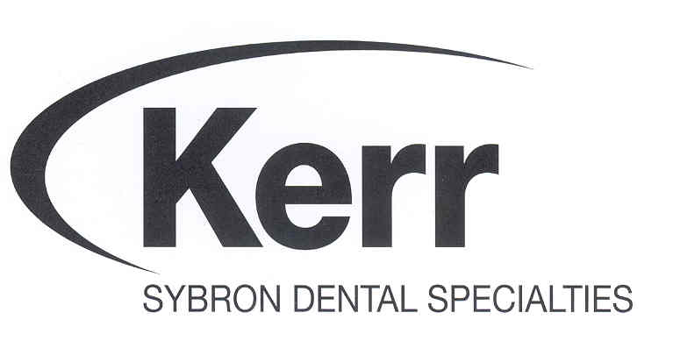The current Corporate members are

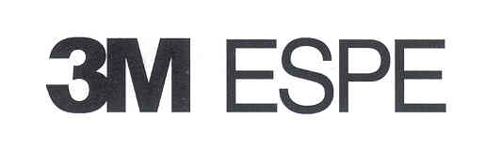



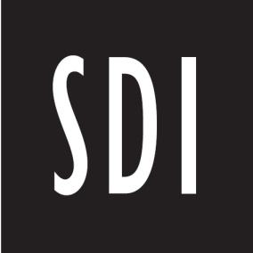





**… in an ancient castle**

**WÜRZBURG**

**GERMANY**

Abstract Submission Deadline: July 1, 2008

1. **Dr. Norbert Hofmann (Norbert.Hofmann@mail.uni-wuerzburg.de)**

**Phone: 49 (0)931 201 72480 , Web Site: www.academydentalmaterials.org**

**For Information Contact:**