ACADEMY OF DENTAL MATERIALS
NEWSLETTER
www.academydentalmaterials.org

Lorenzo Breschi, Secretary ADM November, 2009.

Message from the President

In this second message written during my presidency, I’d like to inform all ADM members of the status of our Academy and where we are headed.
The annual ADM meeting in Portland was a great success, mainly due to the local and scientific organization done by Jack Ferracane, Tom Hilton and Ron Sakaguchi. Special thanks to Dea Dea Hilton, Jennifer Mitchell and Claire Sakaguchi for their support.
The Meeting theme was “Adhesion in Dentistry – Analyzing Bond Strength Testing Methods, Variables and Outcomes” and an excellent program with top-level speakers went through many important issues related to daily research procedures. The relation between laboratory tests and clinical implications was clarified; a critical assessment was provided of the various test methods used for dentin and enamel bonding studies in order to identify general trends, important variables to be considered, and their relation with outcomes. I’m sure that the results of this conference will represent a great background for a future meeting whose goal might be the achievement of consensus about what should be included in bond strength testing and which method may be most accurate, reliable and preferred. Researchers presented almost 70 posters. There was wonderful participation in the Paffenbarger competition among young dental materials researchers. The awards for the Paffenbarger Award, were increased by the Board for this year. The winners were: Julian Leprince (Universitè Catholic de Leuven), Marcìa Borba (University of Sao Paulo) and Renan Belli (Univerity of Erlangen).
During the Meeting, the ADM honored Dr. Grayson William (Bill) Marshall with the ADM Founder’s Award. A special thanks went to Ron Sakaguchi, who decided to retire from the position of Associate Editor of Dental Materials. Bill and Ron provided outstanding service to the Academy, and we are sure they will continue to support the ADM in the future.
The Board is very happy and proud of the high scientific standard achieved by Dental Materials, which retained for the second year a top position in the impact factor dental journal list. the Editor’s report will provide more details on the status of the journal. The economic situation of the ADM continues to be strong and the Treasurer’s report will provide additional information on the financial status of the Academy.
Another important project that has occupied a lot of time and effort is upgrading the Academy’s website. Special thanks go to Sharukh Khajotia and DeaDea Hilton for their dedicated work on this project. When completed, the new website will provide important functional upgrades that should provide better services and more convenience to Academy members.
Because of board changes in recent years, the orderly succession of board members had become disorganized. Last year, the three immediate past-presidents agreed to serve one-year terms to allow the normal succession of two board members rotating off the board per year to be re-established. These individuals completed their appointment at the Annual Meeting and we want to thank Jack Ferracane, Susanne Scherrer and Dorin Ruse for once again coming to the service of the ADM. Also, we want to welcome the three new members-at-large: Paulette Spencer, Ulrich Lohbauer and Nick Silikas, and Milena Cadenaro, who took over the ‘transactions’ Editor position.

Finally, a preview of the the 2010 ADM Annual Meeting was presented. The meeting will be held in Trieste (Italy) and the local organizers will be Prof. Lorenzo Breschi (ADM Secretary) and Milena Cadenaro (ADM Transactions Editor). You will find the final program for 2010 Annual Meeting attached to this newsletter. We hope to see you all in Trieste on 7-9 October 2010!

Marco Ferrari
President, ADM (2009-2010)

Tresurer’s Report

The Academy is in good financial shape. Our cash/cash-equivalent assets stand at $488,336 as of the 2009 annual meeting. This figure includes most of the income for the Portland meeting, but most of the expenses will be paid after the meeting. Current membership is 281. Following last year’s biannual audit of the Academy’s finances, conducted by Woodbridge and Erickson, CPAs, Portland, Oregon, USA, the ADM’s accountants recommended that our funds be dispersed to two accounts to provide more security of the Academy’s assets. In compliance with this recommendation, another bank account was opened, so that the assets are now in two separate institutions: Wells Fargo and U.S.Bank. This ensures that the entire ADM assets are covered by FDIC protection. The Academy’s funds are distributed in conservative, safe instruments, including savings, checking, money market accounts.
A nine-month CD matured in the past year. Since the return on CD’s at the time of maturity was no greater than that obtained with savings or money market accounts, the CD funds were placed into these other accounts that avoid early removal penalties.
After the board reviewed the financial status of the Academy, they approved maintenance of the current fund level for operating expenses of the Academy.

Tom Hilton
Treasurer ADM (2008-2012)

Dental Materials Editors’ Report
December 2009.

This has been an important year for our journal. At the ADM Meeting in Portland in October, it was announced that our North American Associate Editor, Ron Sakaguchi, decided to complete his term of office. Ron has recently been awarded an MBA degree and his University role brings additional responsibilities and research directions. We are immensely grateful to Ron Sakaguchi for his long and distinguished service to the journal and the Academy. We were able to make a suitable presentation to him in Portland to express our collective appreciation. Very recently a number of distinguished scientists in our field have been added to the Editorial Board, and you can see further details in the January 2010 issue. The Abstracts from the Annual Meeting, and also the papers presented, will be available online - coincident with the appearance of the February issue, 26(2). We anticipate a similar, and possibly even faster, treatment of contributions to the forthcoming 2010 meeting in Trieste, Italy. We continue to receive excellent professional support from Elsevier, including conference sponsorship, and in Portland we welcomed our new Senior Publisher from Elsevier – Jane Ryley. Jane is a Canadian citizen resident in St Louis, US. During the past year, the latest Impact Factors showed that Dental Materials maintains a high rank position. It is evident from the increasing submissions (over 700) and downloads (over 0.5 Million) in 2009 that the journal is becoming very widely known amongst scientists beyond the ‘classical boundaries’ of our subject area and constituency. Let us all strive, therefore, (a) to broadcast these facts in our Dental Schools and (b) to increase the membership of the Academy – perhaps each of us could aim to recruit at least one new member in 2010.

David Watts, Editor

New Academy of Dental Materials Website

The Academy’s new website is currently being tested before its launch. The new site will permit the payment of membership dues, the submission of applications for new membership, the submission of abstracts for the annual meeting, and the payment of registration fees for the annual meeting, among other online functionalities. Financial transactions will be conducted via a secure site that permits payment by credit card.

Renewal forms are currently being accepted via email, fax or mail. The URL for the new website will remain the same as the current site (http://www.academydentalmaterials.org). We look forward to revealing the new website soon.

Sharukh Khajotia

Fellowships and Awards

Fellowships
This year the following members have received Fellowship status:
Burak Taskonak (Indiana University – USA)
Dorin Ruse (University of British columbia - Canada)
Huakun (Hockin) Xu (University of Maryland – USA)
Milena Cadenaro (University of Trieste - Italy)

Emeritus Status
Congratulations to Grayson William (Bill) Marshall, he was granted Emeritus status unanimously by the Board.
If you wish to be considered for Fellowship of this Academy then you should consider the criteria for Fellowship as stated below.
Fellows shall be active Members who have attained a high level of achievement in the field of dental materials research. Those Members who are recognized to have advanced dental materials research shall be considered for Fellowship by the Fellowship and Awards Committee. Members awarded Fellowship status shall be inducted into Fellowship at the next annual meeting. Fellows maintain the same rights, privileges, and responsibilities of Members.
Specific guidelines for Fellowship status are:
- Achievement of advanced degrees: at least a master's degree and preferably a Ph.D., Odont Dr., or equivalent degree;
- Evidence of contribution: publication of at least ten (10), peer-reviewed, scientific articles in refereed journals. The candidate should be first author on one-half of the articles; and
- Longevity of commitment to the field: at least five (5) years of leadership through research, training, service and/or education beyond formal education, and normally at least five (5) years membership in the Academy.
If you are interested in becoming a Fellow of this Academy then please submit a curriculum vitae and letters of recommendation from a minimum of two Fellows of the Academy to the secretary: Lorenzo Breschi, email: lbreschi@units.it

Paffenbarger Award
This competition recognizes students who present the most excellent research at our annual conference. This year the winners are:
- Julian Leprince et al. (Universitè Catholique de Louvain). Lucirin-TPO: Photoinitiator Reactivity and Curing Time Reduction.
- Màrcia Borba et al. (University of Sao Paulo). Fracture Load of All-Ceramic Fixed Partial Dentures.
- Renan Belli et al. (Erlangen, Germany). Mefp-1based Peptides as Hydrophilic
Adhesives: Bonding to Zirconia.
The Paffenbarger award winner received a plaque, a money prize of US $1,750 and free registration for the following ADM meeting; second place received a certificate, a money prize of US $1,250 and free registration for the following ADM meeting; and third place received a certificate a money prize of US $1,000 and free registration for the following ADM meeting.

Burak Taskonak
Member at Large ADM (2008-2012)

Future Meetings
Please reserve the following dates on your calendar. We look forward to the upcoming meeting in:
2010: Trieste (Italy) October 8-10, 2010
2011: Brazil

Detailed program and info for the 2010 meeting are reported at the end of the newsletter.
Executive Committee of the Academy
President (2008-2010): Marco Ferrari
md3972@mclink.it
Vice President (2008-2010): Alvaro Della Bona
dbona@upf.br
Secretary (2008-2010): Lorenzo Breschi
lbreschi@units.it
Treasurer (2008-2012): Tom Hilton
hiltont@ohsu.edu
Past President(2008-2010): Jason A. Griggs
JGriggs@sod.umsmed.edu
Members-At-Large:
Laurence Mair (2008-2012)
l.h.mair@liverpool.ac.uk
Paulo F. Cesar (2008-2012)
paulofc@usp.br
Burak Taskonak (2008-2012)
btaskona@iupui.edu
Paulette Spencer (2009-2013)
spencerp@umkc.edu
Ulrich Lohbauer (2009-2013)
lohbauer@dent.uni-erlangen.de
Nick Silikas (2009-2013)
nick.silikas@manchester.ac.uk
Transactions Editor: Milena Cadenaro
m.cadenaro@fmc.units.it
Paffenbarger Award: to be appointed
Webmaster: to be appointed
Membership Chair: Susanne Scherrer
Susanne.Scherrer@unige.ch
Fellowship and Student Awards: Lorenzo Breschi
lbreschi@units.it

Dental Materials:
Editor: David Watts
david.watts@man.ac.uk
Associate Editor: to be appointed

The current Corporate members are
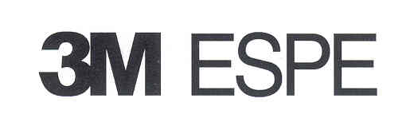


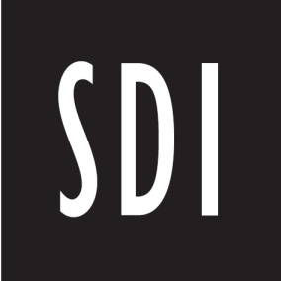



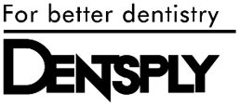

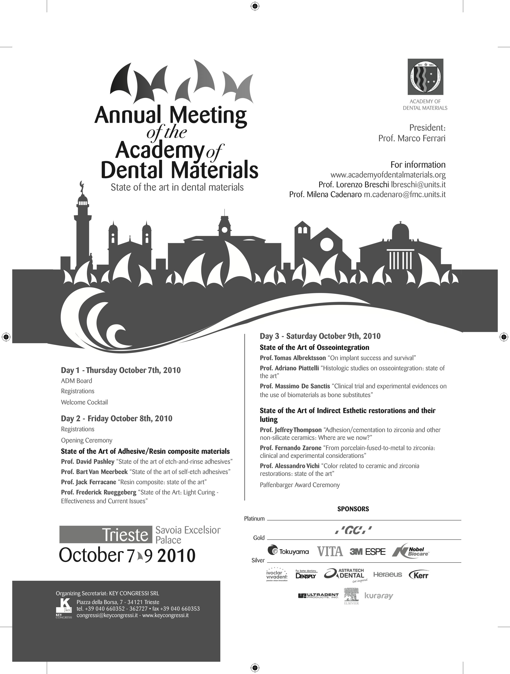
WÜRZBURG

GERMANY

… in an ancient castle
For Information Contact:
- Dr. Norbert Hofmann (Norbert.Hofmann@mail.uni-wuerzburg.de)
Phone: 49 (0)931 201 72480 , Web Site: www.academydentalmaterials.org

